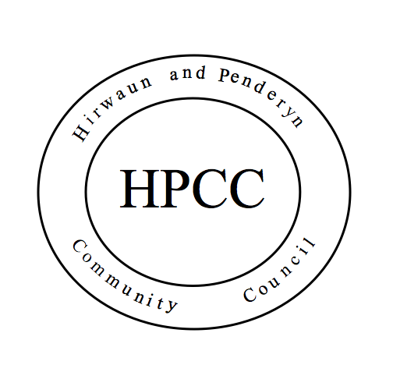
Hirwaun & Penderyn Community Council
Small Grants Scheme
Application for Grant
We welcome applications for grant funding primarily from community groups in Hirwaun and Penderyn.

Who and how will we support?
The Community Council wishes to focus on supporting the local community. Grants will be considered for local voluntary groups and charities. All grant applications will be considered on their individual merits.

When deciding on the allocation of grants, we will give consideration to the following criteria:
- Is the organisation based in our Community Council area, or supports the residents of our area?
- Grants for a specific purpose will have priority over those to support the general activities of the organisation;
- Will the grant enable more local people to apply for funding from other organisations?

If you need assistance to complete this form, please contact the Executive Officer on hpcc01@btconnect.com or 01685 812850.
Application Form
Your organisation
Name of organisation

Purpose of organisation

Your application
Why do you need a grant?

What is the total cost of your requirements? Please provide quotes

How will any monies raised by a successful grant be used?

How much are you asking the Community Council for?

Who will benefit from this grant?

Additional Information:
Please attach the following to your application:
- Current bank statement, from all bank accounts held (including bond or trust accounts).
- Your constitution, governing document, or aims and objectives.
- Details of any applications made/received to other grant giving bodies.

Conditions of Grant
Grants will be given subject to the following conditions:
1. Beneficiaries agree that they will refer to Community Council support in their record/promotional materials.
2. Hirwaun & Penderyn Community Council will put details of the organisation and the grant paid to them on the Community Council website.
3. Depending on the nature of the request the Community Council reserves the right to impose other conditions.

Your contact details for the purpose of this application
Cheque payable to

Name of applicant

Contact address

Email address

Signature

Date

