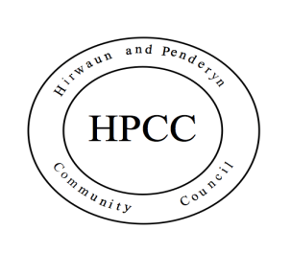
Hirwaun & Penderyn in Bloom Competition 2020
Entry Form
This competition is open to all residents of the villages of Hirwaun and Penderyn and aims to promote a sense of pride in their gardens/allotments. Free entry. Judging will take place on Saturday 18th July 2020.
Your Details
Title
First Name
Surname
Address

Postcode
Telephone
Signature
I agree that HPCC can hold my details for the purposes of this competition only and that HPCC can contact me in relation to this competition. I am able to request that my details be removed at any time.
Photographs of the winning entries will be displayed on the Community Council website.
Date
Email

Please Tick to indicate your entry  (1 entry only from below) |  | Please Tick to indicate your entry  (1 entry below can be entered alone or in addition to front garden)
Best Front Garden |  | Best Bee Friendly Back Garden
Best Bee Friendly Front Garden |  | Allotment Plot
Hanging Baskets or Planter - Front Garden

Please return your competed form to: Executive Officer, Hirwaun & Penderyn Community Council, The Village Hall, High Street, Hirwaun, CF44 9SL
Categories for each village will include:

- Best Front Garden (must be clearly visible from the roadside)
The goal for this entry is to find the display with the most impact – size is not a factor.
- Best Bee Friendly Front Garden (must be clearly visible from the roadside)
The goal for this category is to find the garden with the best display of bee friendly plants and flowers.
- Best Hanging Baskets or Planter (must be clearly visible from the roadside)
The goal for this category is to find the display with the most impact.
- Best Bee Friendly Back Garden (you must be available on the day to give us access to judge this). The goal for this category is to find the garden with the best display of bee friendly plants and flowers.
- Best Allotment Plot
The goal for this category is to find the best kept allotment plot.

Cash prizes will be awarded for the winning entries.
1st Prize for each category - £20
2nd Prize for each category - £15
3rd Prize for each category - £10

Rules of entry:
- All entries must fall within the Wards of Hirwaun and Penderyn.
- Entries are open to individuals, community groups and businesses.
- All entrants must complete and sign an entry form.
- Only one front garden entry per household will be accepted. In addition to a front garden entry, you are able to submit a back garden or allotment plot entry.
- Entries must be submitted by the closing date which is Monday 6th July 2020.
- Judging will take place on 18thJuly 2020 from 10am onwards.
- Unsuccessful entrants will be notified by email or letter.
- No correspondence will be entered into and the judge’s decision will be final.

